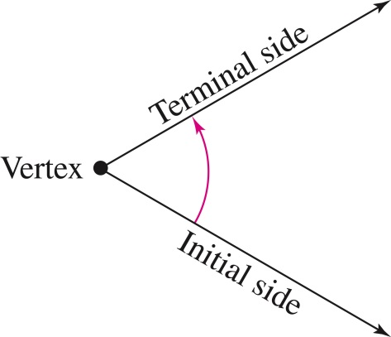
AC Precalculus
Unit 1: Trigonometry

Lesson 4.1: Radian and Degree Measure (Day 1)

Objective: In this lesson you will learn how to describe an angle and to convert between radian and degree measure.
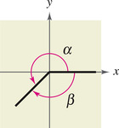
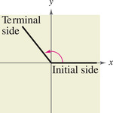
Trigonometry as derived from the Greek language means “measurement of triangles.”
angle
initial side
terminal side
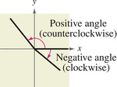
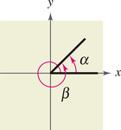
standard position
positive angles
negative angles
coterminal

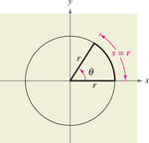
Radian Measure
The measure of an angle is determined by the amount of rotation from the initial side to the terminal side. One way to measure angles is in radians.
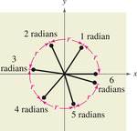
Definition of Radian
One radian is the measure of a central angle θ that intercepts an arc s equal in length to the radius r of the circle. Algebraically this means that $θ=\frac{s}{r}$
where θ is measured in radians.
$$s=2πr$$

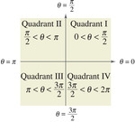
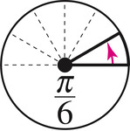
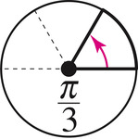
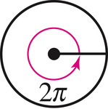
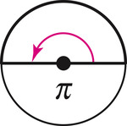
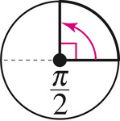
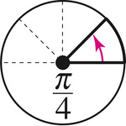

Note that angles between 0 and $π/2$ are acute angles and angles between $π/2$ and $π$ are obtuse angles.
Two angles are coterminal if they have the same initial and terminal sides. You can find an angle that is coterminal to a given angle $θ$ by adding or subtracting $2π$ (one revolution). A given angle $θ$ has infinitely many coterminal angles.

Example 1: Find a coterminal angle to each given angle by adding and subtracting $2π$.
- $\frac{13π}{6}$ b. $\frac{3π}{4}$ c. $\frac{9π}{4}$ d. $-\frac{3π}{4}$

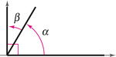
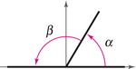
Two positive angles $α$ and $β$ are complementary (complements of each other) if their sum is $\frac{π}{2}$. Two angles are supplementary (supplements of each other) if their sum is $π$.

Example 2: If possible, find the complement and the supplement of the angle.
- $\frac{π}{6}$ b. $\frac{5π}{6}$ c. $\frac{2π}{5}$ d. $\frac{π}{4}$

AC Precalculus
Unit 1: Trigonometry

Lesson 3.2B: Applications of Radian Measure

Objective: In this lesson you will learn how to use radian measure to solve problems.

Arc Length of a Circle
The length s of the arc intercepted on a circle of radius r by a central angle of measure $θ$ radians is given by the product of the radius and the radian measure of the angle:
_____________________

Example 1: A circle has a radius of 18.2 centimeters. Find the length of the arc intercepted by a central angle having each of the following measures.
- $\frac{3π}{8}$ radians b. $\frac{4π}{5}$ radians

Example 2: Reno, Nevada, is approximately due north of Los Angeles The latitude of Reno is $40°N$, while that of Los Angeles is $34°$N. (The N means north of the equator). If the radius of Earth is 6400 kilometers, find the north-south distance between the two cities.

Example 3: A rope is being wound around a drum with radius .8725 feet. How much rope will be wound around the drum if the drum is rotated through an angle of $39.72°$?

Example 4: Two gears are adjusted so that the smaller gear drives the larger one. If the smaller gear rotates through $225°$, through how many degrees will the larger gear rotate?

Area of a Sector
The area of a sector of a circle of radius r and central angle $θ$ is given by:

_________________________

Example 5: Using the picture, where the central angle is $15°$ and the radius of the circle is 321 meters, find the area of the field.

AC Precalculus
Unit 1 – Trigonometry

Lesson 4.1: Radian and Degree Measure (Day 2)

Objective: In this lesson you will learn how to describe an angle and to convert between radian and degree measure and use angles to model and solve real life problems.
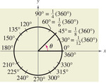
Degree Measure
A second way to measure angles is in terms of degrees, denoted by the symbol $°$. A measure of one degree $(1°)$ is equivalent to a rotation of $\frac{1}{360}$ of a complete revolution about the vertex.

Conversion Between Degrees and Radians
- To convert degrees to radians, multiply by $\frac{π rad}{180°}.$
- To convert radians to degrees, multiply radians by $\frac{180°}{π rad}$.
To apply these two conversion rules, use the basic relationship $π rad=180°$.

If no units of angle measure are specified, radian measure is implied.
Example 1: Express each of the following angles in radian measure as a multiple of $π$.
- $60°$ b. $320°$ c. $-30°$ d. $540°$

Example 2: Express the following angles in degree measure.
- $-\frac{π}{2}$ b. $\frac{π}{6}$ c. $\frac{5π}{3}$ d. $3$

Applications
The radian measure formula, $θ=s/r$, can be used to measure arc length along a circle.
Example 3: Find the length of the arc intercepted by the given central angle with the given radius.
- Central Angle of $240°$ and radius of 4 inches b. Central angle of $160°$ and radius of 27 in

AC Precalculus
Unit 1 - Trigonometry

Lesson 4.2: Trigonometric Functions: The Unit Circle

Objective: In this lesson you will learn how to identify a unit circle and its relationship to the real numbers. You will also learn how to use the domain and period to evaluate sine and cosine functions.
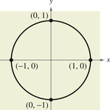
Consider the unit circle given by $x^{2}+y^{2}=1$ Center = ______ Radius = ____

Imagine that a real number line is wrapped
around this circle, with positive numbers
corresponding to a counterclockwise wrapping
and negative numbers corresponding to a
clockwise wrapping.

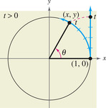
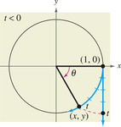
As the real number line is wrapped around the unit circle, each real number corresponds to a point (x, y) on the circle.

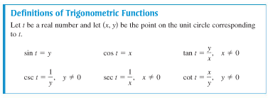

$30°-60°-90°$ $45°-45°-90°$

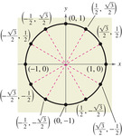
Example 1: Evaluate the six trigonometric functions at each real number.
- $t=\frac{π}{6}$

- $t=\frac{2π}{3}$

- $t=\frac{5π}{4}$

- $t=0$ e. $t=π$ f. $t=\frac{π}{2}$

g. $t=2π$ h. $t=-\frac{π}{3}$ i. $t=-\frac{π}{4}$

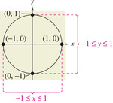
j. $t=\frac{9π}{4}$ k. $t=\frac{11π}{3}$

The domain of the sine and cosine functions is the set of all real numbers. To determine the range of these two functions, consider the unit circle.

$\sin\left(t+2πn\right)=\sin{t}$ $\cos\left(t+2πn\right)=\cos{t}$

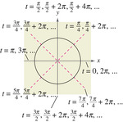
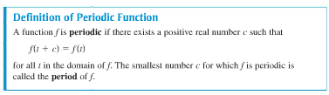

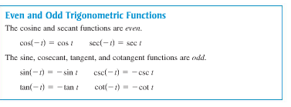

Example 1: Find the following:
- $\cos{\frac{9π}{3}}$ b. $\sin{(-\frac{11π}{3})}$ c. $\sin{\frac{13π}{6}}$

d. $\cos\left(-\frac{7π}{6}\right)$ e. If $\tan\left(t\right)=\frac{2}{3}$, find tan(-t) f. If sin t = $\frac{4}{5},$find sin (-t)

Example 2: Use a calculator to evaluate.
- $\sin{\frac{5π}{7}}$ b. $\csc{2}$ c. $\cot{1.5}$

AC Precalculus
Unit 1 – Trigonometry

Lesson 3.3B: Circular Functions of Real Numbers

Objective: In this lesson you will use a calculator to find the approximation for each circular function value.

Circular Functions

$\sin{x}=$_____ $\cos{x}=$_____ $\tan{x}=$______

$\csc{x}=$_____ $\sec{x}=$_____ $\cot{x}=$______

Domains of the Circular Functions
The domains of the circular functions are as follows. Assume that n is any integer and s is a real number.

Sine and Cosine Functions: _________________________________________________

Tangent and Secant Functions:_______________________________________________

Cotangent and Cosecant Functions:___________________________________________

Example 1: Find the exact circular function value for each of the following:
  - $\cos{\frac{2π}{3}}$ b. $\tan\left(-\frac{π}{4}\right)$

c. $\csc{\frac{10π}{3}}$ d. $\sin{\frac{5π}{6}}$

Example 2: Use a calculator to find an approximation for each of the following circular function values.
- $\cos{.5149}$ b. $\cot{1.3209}$ c. $\sec\left(-2.9234\right)$

Example 3: a. Find the value of s in the interval $\left[0, \frac{π}{2}\right]$ that has $\cos{s}= .96854556.$

- Find the exact value of s in the interval $\left[0, \frac{π}{2}\right]$ for which $\sin{s=\frac{\sqrt{2}}{2}}$.

AC PreCalculus
Unit 1 – Trigonometry

Lesson 3.4B: Linear and Angular Velocity

Objective: In this lesson you will learn how to solve real life problems involving linear and angular velocity.

In many situations it is necessary to know at what speed a point on a circular disk is moving or how fast the central angle of such a disk is changing. Some examples occur with machinery involving gears or pulleys or the speed of a car around a curved portion of highway.

Suppose that point P moves at a constant speed along a circle of radius r and center O. The measure of how fast the position of P is changing is called _________________________________________.

If v represents linear velocity, then

where s is the length of the arc traced by point P at time t.

As point P moves along the circle, ray OP rotates around the origin. Since the ray OP is the terminal side of angle POB, the measure of the angle changes as P moves along the circle. The measure of how fast angle POB is changing is called __________________________________________.

Angular velocity, written _____, can be given as

where $θ$ is the measure of angle POB at time t.

Recall that the length s of the arc intercepted on a circle of radius r by a central angle of measure $θ$ radians is _________________.

Angular and Linear Velocity

ANGULAR VELOCITY LINEAR VELOCITY

Example 1: Suppose that point P is on the circle with radius of 10 centimeters, and ray OP is rotating with angular velocity of $\frac{π}{18}$ radians per second.
- Find the angle generated by P in 6 seconds.

- Find the distance traveled by P along the circle in 6 seconds.

- Find the linear velocity of P.

In practical applications, angular velocity is often given as revolutions per unit of time, which must be converted to radians per unit of time before using the formulas given.

Example 2: A belt runs a pulley of radius 6 centimeters at a rate of 80 revolutions per minute.
- Find the angular velocity of the pulley in radians per second.

- Find the linear velocity of the belt in centimeters per second.

Example 3: A satellite traveling in a circular orbit 1600 kilometers above the surface of the Earth takes two hours to make an orbit. Assume that the radius of the Earth is 6400 kilometers.
- Find the linear velocity of the satellite.

- Find the distance traveled in 4.5 hours.

AC PreCalculus
Unit 1 - Trigonometry

Lesson 4.1: Radian and Degree Measure (Day 3)

Objective: In this lesson you will use angles to model and solve real life problems.

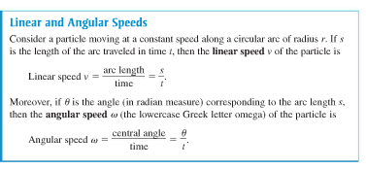
The formula for the length of a circular arc can be used to analyze the motion of a particle moving at a constant speed along a circular path.
Linear speed measures how fast the particle moves, and angular speed measures how fast the angle changes.
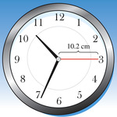
Example 1: The second hand of a clock is 10.2 centimeters long. Find the linear speed of the tip of the second hand as it passes around the clock face.

Example 2: The blades of a wind turbine are 116 feet long. The propeller rotates at 15 revolutions per minute.
- Find the angular speed of the propeller in radians per minute.
- Find the linear spee
- d of the tips of the blades.

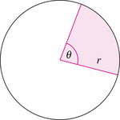
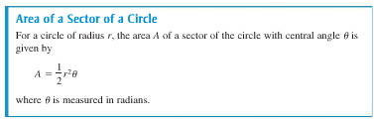
A sector of a circle is the region bounded by two radii of the circle and their intercepted arc.

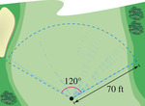
Example 3: A sprinkler on a golf course fairway sprays water over a distance of 70 feet and rotates through an angle of $120°$. Find the area of the fairway watered by the sprinkler.

Example 4: A sprinkler on a golf course is set to spray water over a distance of 75 feet and rotates through an angle of $135°$. Find the area of the fairway watered by the sprinkler.

Example 5: The circular blade on a saw rotates at 2400 revolutions per minute.
- Find the angular speed in radians per second.
- The blade has a radius of 4 inches. Find the linear speed of a blade tip in inches per second.

AC Precalculus
Lesson 4.1 – APPLICATIONS NAME:____________________

FORMULAS
Length of Arc Linear Speed Angular Speed Area of a Sector

$s=r θ$ $v=\frac{s}{t}$ $ω=\frac{θ}{t}$ $A=\frac{1}{2}r^{2}θ$
$v=\frac{rθ}{t}$
$v=rω$
Problems:
- A circle has a radius of 18.2 centimeters. Find the length of the arc intercepted by a central angle having each of the following measures.
  - $\frac{3π}{8} radians$ b. $144°$

- Find the exact length of the arc intercepted by the given central angle.
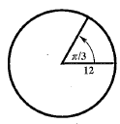
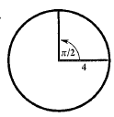
  - b.

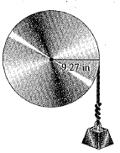

- a. How many inches will the weight in the figure rise if the pulley is rotated
through an angle of $71°{50}^{'}?$
b. Through what angle, to the nearest minute, must the pulley be rotated to
raise the weight 6 inches?
$r=9.27$in

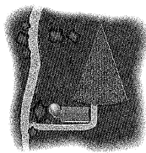
- The picture shows a field in the shape of a sector of a circle. The central angle is $15°$ and the radius of the circle is 321 meters. Find the area of the field.

- Find the area of the sector of a circle having radius r and central angle $θ$.
  - $r=29.2$m, $θ=\frac{5π}{6}$ b. $r=12.7$ cm, $θ=81°$

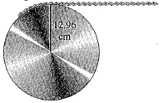
- The pulley shown has a radius of 12.96 cm. Suppose it takes 18 sec for 56 cm of the belt to go around the pulley. Find the angular velocity of the pulley in radians per second.

- A belt runs a pulley of radius 6 centimeters at 80 revolutions per minute.
  - Find the angular velocity of the pulley in radians per second.
  - Find the linear velocity of the belt in centimeters per second.

- A tire with a 9 inch radius is rotating at 30 mph. Find the angular velocity of a point on its rim. Express the result in radians per minute.

- If a wheel with a 16 inch diameter is turning at 12 rev/sec, what is the linear speed of a point on its rim in ft/min?

- The wheel of a machine rotates at the rate of 300 rpm (rotations per minute). If the diameter of the wheel is 80 cm, what are the angular (in radians per second) and linear speed (in cm per second) of a point on the wheel?

- Dan Druff and Ella Funt are riding on a Ferris wheel. Dan observes that it takes 20 s to make a complete revolution. Their seat is 25 ft from the axle of the wheel.
  - What is their angular velocity in radians per minute?
  - What is their linear velocity?

- David puts a rock in his sling and starts whirling it around. He realizes that in order for the rock to reach Goliath, it must leave the sling at a speed of 60 ft/s. So he swings the sling in a circular path of radius 4 ft. What must the angular velocity be in order for David to achieve his objective?

- Patrick is riding a racing bike at a speed of 50.4 kilometers per hour. The wheels have a diameter of 70 centimeters. Find the angular velocity of the wheels in radians per second.

- Find the length of the arc intercepted by a central angle $θ$ in a circle of radius r.
  - $r=12.3$cm, $θ=\frac{2π}{3}$ b. $r=4.82$m, $θ=60°$

- The crankshaft pulley of a car has a radius of 10.5 cm and turns at 6$π$ rad/sec. What is the linear speed of the pulley?

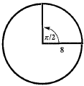
- Find the area of the sector.
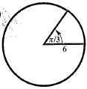
  - b.

- A cylinder with a 2.5 ft radius is rotating at 120 rpm.
  - Give the angular velocity in rad/sec.
  - Find the linear velocity of a point on its rim in mph.

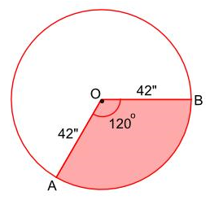
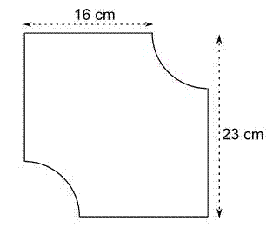

AC Precalculus
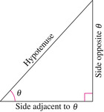
Unit 1 - Trigonometry

Lesson 4.3: Right Triangle Trigonometry

Objective: In this lesson you will learn how to evaluate trigonometric functions of acute angles and how to use the fundamental trigonometric identities. You will also learn how to use the calculator to evaluate trigonometric identities and use the trigonometric functions to model and solve real-life problems.
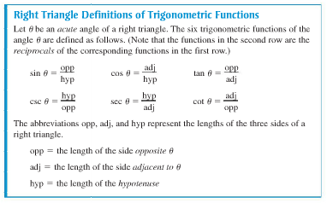

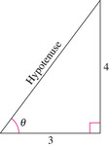

Example 1: Use the triangle to find the values of the six trigonometric functions of $θ$.

Example 2: Find the values of the six trigonometric functions of $θ$ if the hyptotenuse is 4 and the side opposite $θ$ is 2.

Example 3: Find the values of $\sin{45°, \cos{45°, and \tan{45°}.}}$
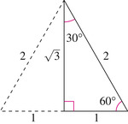
Example 4: Use the equilateral triangle shown to find the values of $\sin{60°, \cos{60°, \sin{30°, \cos{30°,}}and \tan{60°}}}$.

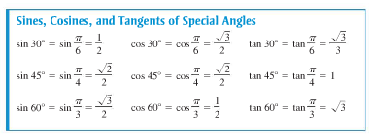
*YOU MUST KNOW THESE VALUES!

Trigonometric Identities
Reciprocal Identities

Quotient Identities

Pythagorean Identities

Example 5: Let $θ$ be an acute angle, such that $\sin{θ=0.6}$. Find the values of (a) cos $θ$ and (b) tan $θ$ using the trigonometric identities.

Example 6: Let $θ$ be an acute angle such that cos $θ$ =0.96. Find the values of (a) sin $θ$ and (b) tan $θ$ using the trigonometric identities.

Example 7: Let $θ$ be an acute angle such that tan $θ$= 3. Find the values of (a) cot $θ$ and (b) sec $θ$ using trigonometric identities.

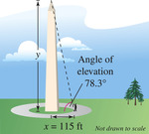
Example 8: A surveyor is standing 115 feet from the base of the Washington Monument. The surveyor measures the angle of elevation to the top of the monument as $78.3°$. How tall is the Washington Monument?

Example 9: A biologist wants to know the width w of a river in order to properly set instruments for studying the pollutants in the water. From point A, the biologist walks downstream 70 feet and sights to Point C which is directly across from point A. From this sighting, it is determined that $θ$ = $54°$. How wide is the river?

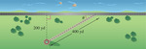
Example 10: A historic lighthouse is 200 yards from a bike path along the edge of a lake. A walkway to the lighthouse is 400 yards long. Find the acute angle $θ$ between the bike path and the walkway.

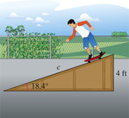
Example 11: Find the length c of the skateboard ramp shown.

Example 12: A ramp $17\frac{1}{2}$ feet in length rises to a loading platform that is 3 ½ feet off the ground. Find the angle $θ$ that the ramp makes with the ground.

AC Precalculus
Unit 1 - Trigonometry

Lesson 4.8: Applications and Models
Lesson 2.4B: Solving Right Triangles

Objective: In this lesson you will learn to solve real life problems involving
right triangles.

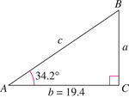
Example 1: Solve the right triangle shown for all unknown sides and angles.

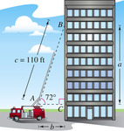
Example 2: A safety regulation states that the maximum angle of elevation for a rescue ladder is $72°$. A fire department’s longest ladder is 110 feet. What is the maximum safe rescue height?

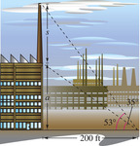
Example 3: At a point 200 feet from the base of a building, the angle of elevation to the bottom of a smokestack is $35°$, whereas the angle of elevation to the top is $53°$, as shown in the picture. Find the height of the smokestack alone.

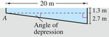
Example 4: A swimming pool is 20 meters long and 12 meters wide. The bottom of the pool is slanted so that the water depth is 1.3 meters at the shallow end and 4 meters at the deep end. Find the depression of the bottom of the pool.

Applications involving Right Triangles
Many applications require finding a measurement that cannot be measured directly: for example, the height of a tree or a flagpole, or the angle formed between the horizontal and the line of sight to the top of a building. These measurements are often found by solving right triangles.
To solve a triangle means to find the measures of all the angles and sides of the triangle.
Many applications of right triangles involve the angle of elevation or the angle of depression.
Angle of Elevation Angle of Depression

Example 5: Shelly McCarthy knows that when she stands 123 feet from the base of a flagpole, the angle of elevation to the top is $26.6°$. If her eyes are 5.30 feet above the ground, find the height of the flagpole.

Example 6: The length of the shadow of a building 34.09 meters tall is 37.62 meters. Find the angle of elevation of the sun.

AC Precalculus
Unit 1 – Trigonometry

Lesson 4.8: Applications and Models
Lesson 2.5B: Further Applications of Right Triangles

Objective: In this lesson you will learn to solve real life problems involving directional bearings.

Other applications of right triangles involve bearing, an important idea in navigation and surveying. There are two common ways to express bearings.
A bearing measures the acute angle that a path or line of sight makes with a fixed north-south line. For instance, the bearing S 35$°$E means 35 degrees east of south.

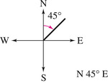
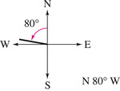
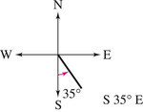

In air navigation, bearings are measured in degrees clockwise from north. Examples of air navigation bearings are shown below.
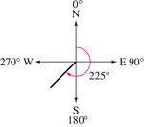
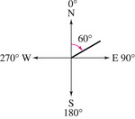

Example 1: A ship leaves port at noon and heads due west at 20 knots, or 20 nautical miles (nm) per hour. At 2 pm the ship changes course to N $54°$ W. Find the ship’s bearing and distance from the port of departure at 3 pm.

Example 2: A sailboat leaves a pier and heads due west at 8 knots. After 15 minutes the sailboat tacks, changing course to N 16$°$W at 10 knots. Find the sailboat’s bearing and distance from the pier after 12 minutes on this course.

Example 3: Radar stations A and B are on an east-west line¸3.7 kilometers apart. Station A detects a plane a C, on a bearing of $61°$. Station B simultaneously detects the same plane, on a bearing of $331°$. Find the distance from A ro C.

Example 4: The bearing from A to C is $S52°E.$ The bearing from A to B is N$84°$E. The bearing from B to C is S$38°$W. A plane flying at 250 miles per hour takes 2.4 hours to go from A to B. Find the distance from A to C.

AC PreCalculus
Unit 1 – Trigonometry

Lesson 4.4: Trigonometric Functions of Any Angle (Day 1)

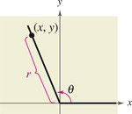
Objective: In this lesson you will learn how to evaluate trigonometric functions of any angle.

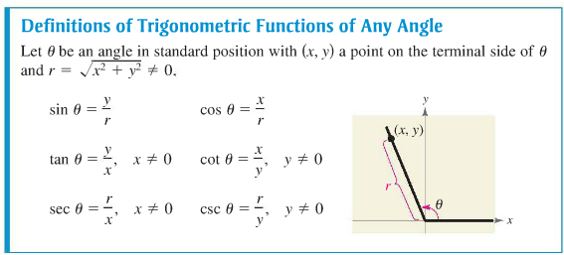
Example 1: Let (-3, 4) be a point on the terminal side of $θ$. Find the sine, cosine, and tangent of $θ$.

Example 2: Let (-2, -3) be a point on the terminal side of $θ$. Find the sine, cosine, and tangent of $θ$.

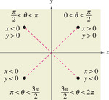

Example 3: Given $\tan{θ=-\frac{5}{4}}$and $\cos{θ>0},$ find $\sin{θ}$ and $\sec{θ}$.

Example 4: Given $\sin{θ}=\frac{4}{5}$ and $\tan{θ<0},$find $\cos{θ}$ and $\csc{θ}$.

Trigonometric Functions of Quadrant Angles
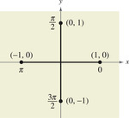
Example 5: Evaluate the cosine and tangent functions at the four quadrant angles, 0, $\frac{π}{2}, π, and \frac{3π}{2}.$

Example 6: Evaluate the cosecant and cotangent functions at 0, $\frac{π}{2}, π, and \frac{3π}{2}.$

AC Precalculus
Unit 1 - Trigonometry

Lesson 4.4: Trigonometric Functions of Any Angle (Day 2)

Objective: In this lesson you will learn how to find reference angles and then evaluate trigonometric functions of these angles.

The values of the trigonometric functions of angles greater than $90°$ (or less than $0°$) can be determined from their values at corresponding acute angles called reference angles.

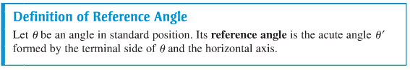

Example 1: Find the reference angle $θ'$.
- $θ=300°$ b. $θ=213°$ c. $θ=-144°$ d. $θ=2.3$

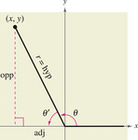
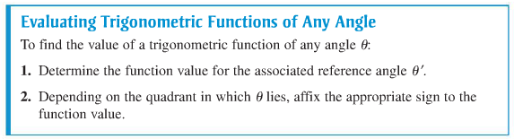
Trigonometric Functions of Real Numbers

Using Reference Angles
Example 2: Evaluate each trigonometric function.
- $\cos{\frac{4π}{3}}$ b. $\tan{-210°}$

c. $\sin{\frac{5π}{3}}$ d. $\cos{(-60°)}$

- $\tan{\frac{11π}{6}}$ f. $\csc{\frac{11π}{4}}$

Example 3: Let $θ$ be an angle in Quadrant II such that sin $θ=\frac{1}{3}$. Find (a) cos $θ$ and (b) tan $θ$ by using trigonometric identities.

Example 4: Let $θ$ be an angle in Quadrant III such that sin $θ=-\frac{5}{13}$. Find (a) sec $θ$ and (b) tan $θ$ by using trigonometric identities.

